K.SUMA

160041036

CAR PARKING SYSTEM

INTRODUCTION:

My project is based on car parking system. In a parking lot wherever cars are there red led will be on and where lot is empty green light will be glowing. Based on the priority of the parking order car will be automatically parked in the order followed by priority. This will make the job of the driver very easy.

FRONT PANEL: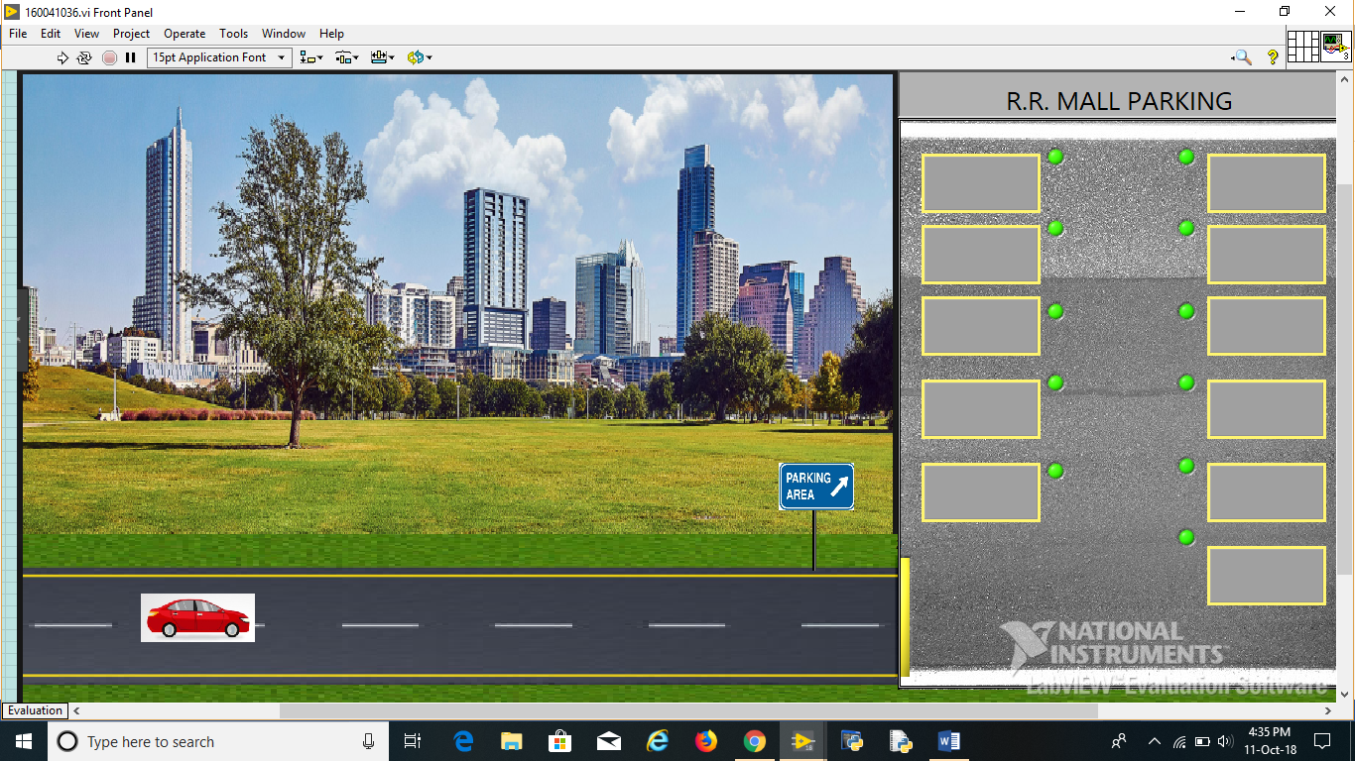

WORKING:

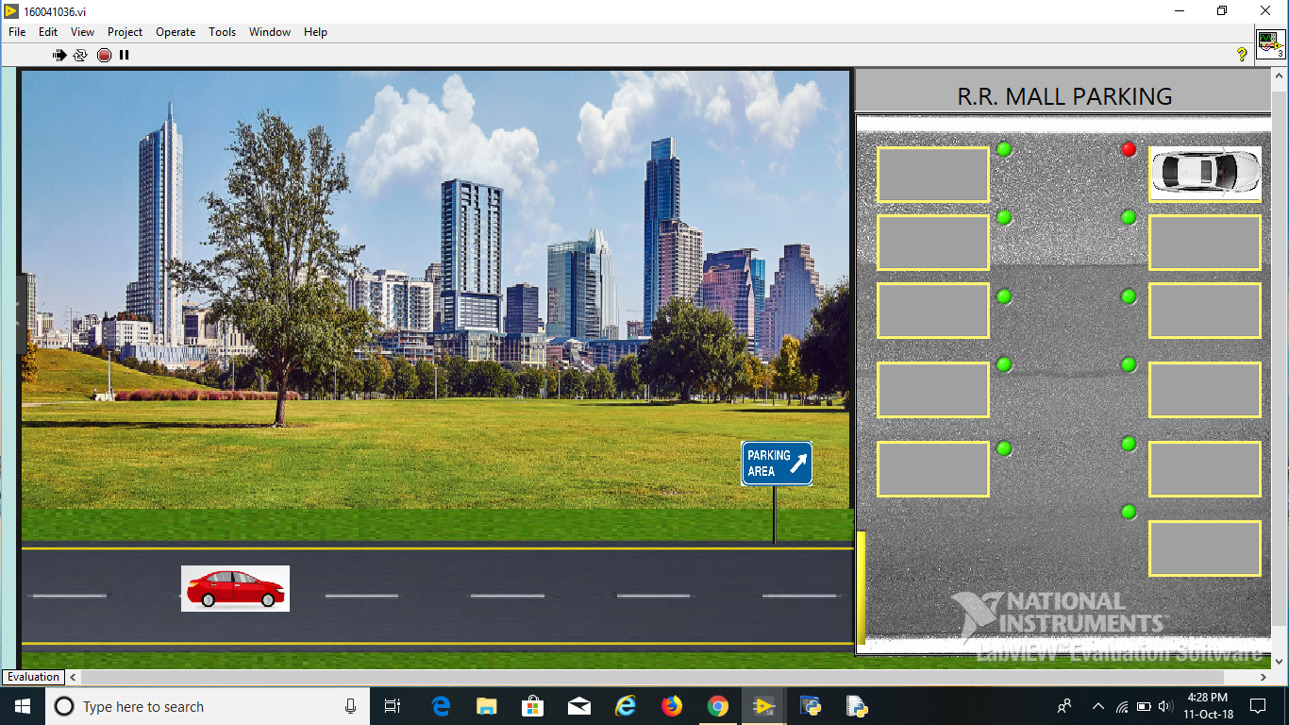

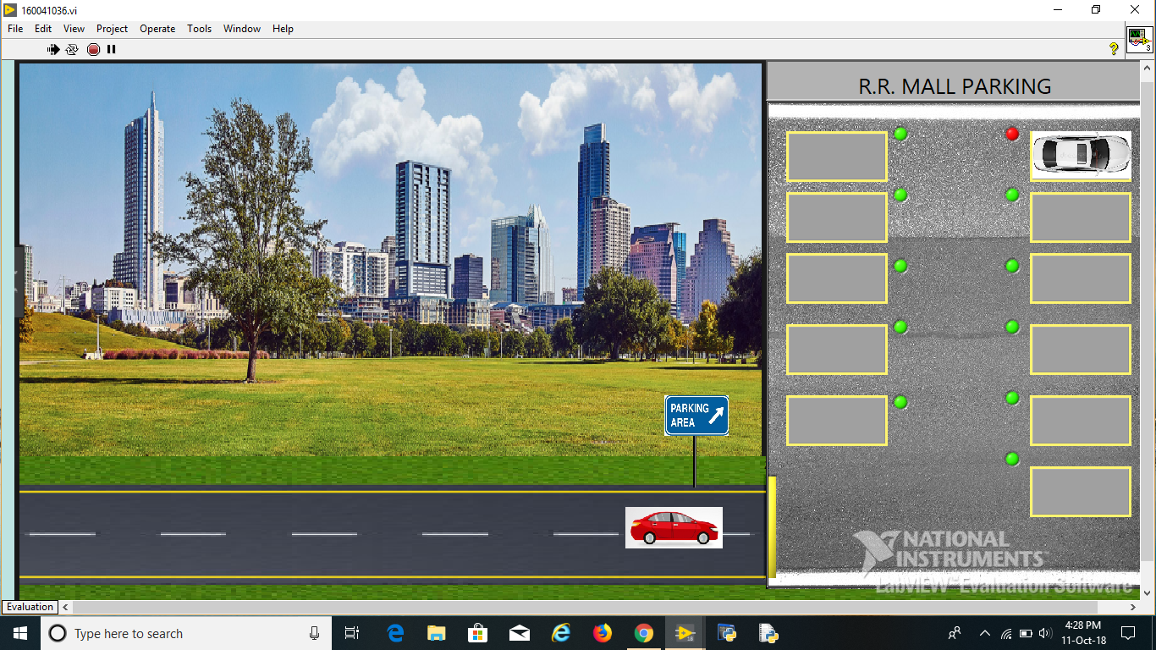

Gate opens automatically

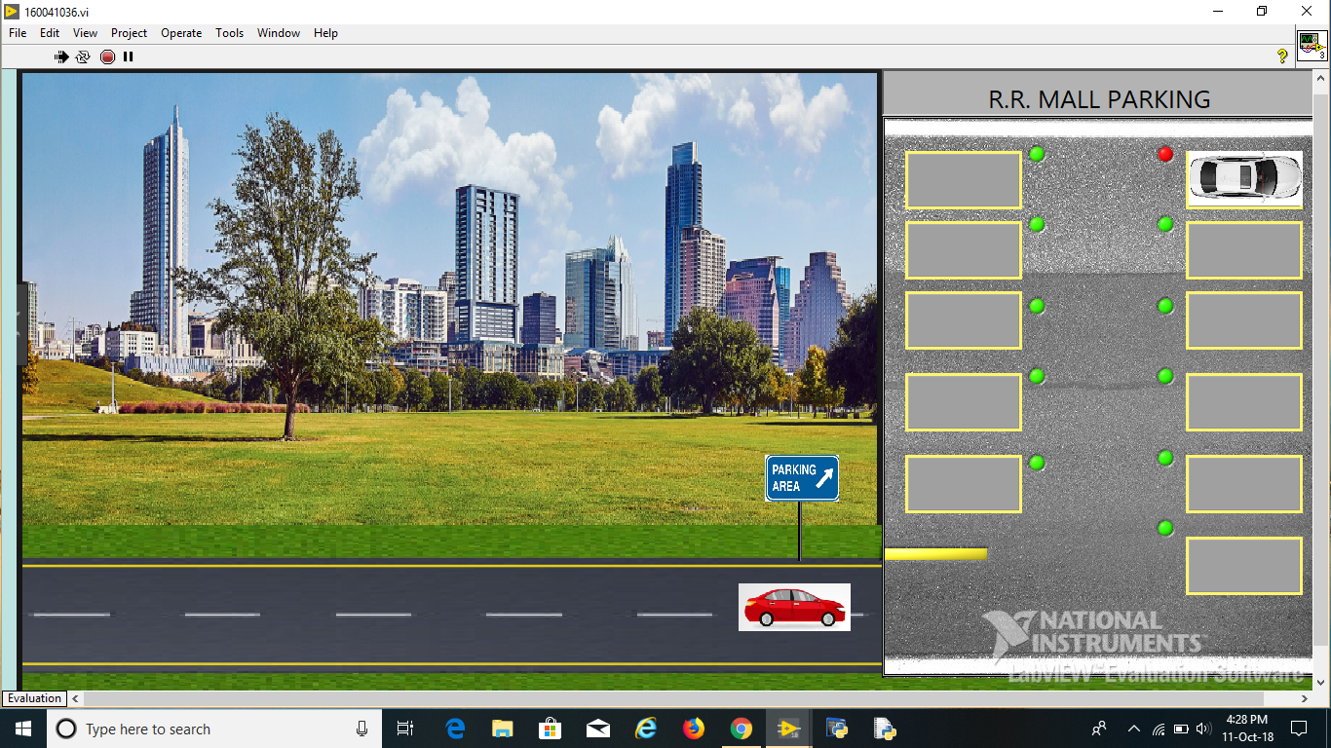

After the car passes through the gate gate will be automatically closed

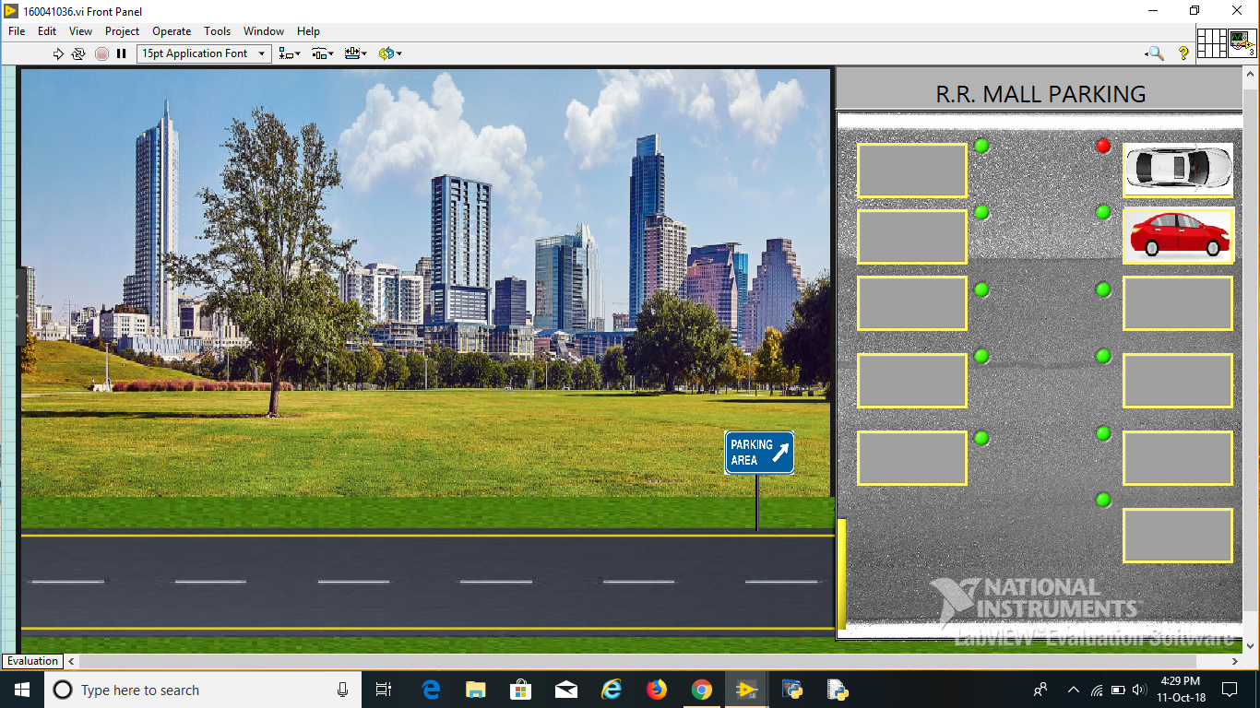

SECOND CASE

